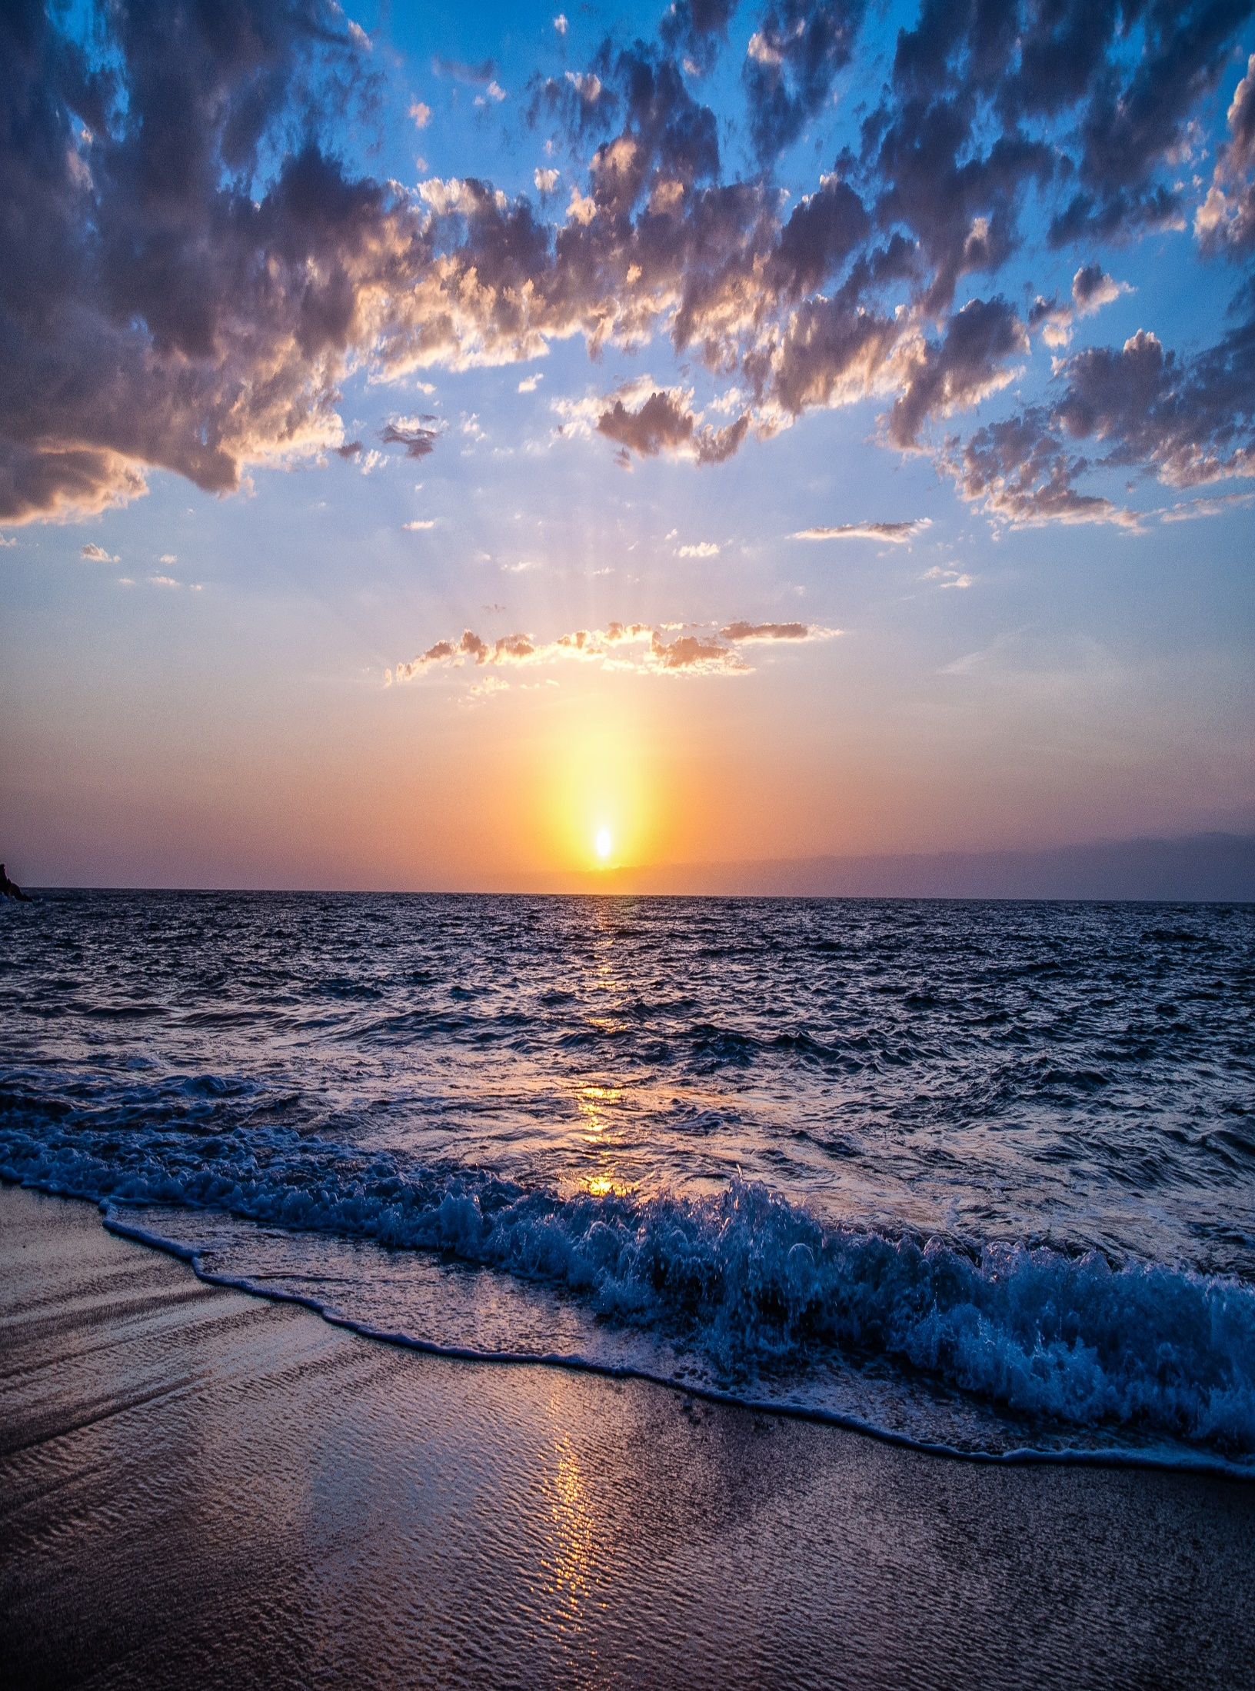

BEAUTY OF BEACHES

***Wajahat Al­i Junaid***

***M.Hadees Arslan***

***Majid Rizwan***

***E-PROJECT***

***6/2/2023***

**6-FEB-2023**

**Date**

CERTIFICATE OF COMPLETION

**M.Hadees**

**Wajahat Ali**

**HAS SUCCESSFULLY COMPLETE**

**COURSE OF STUDY**

**M.Junaid**

**Arsalan**

**Majid**

**Rizwan**

**Signature**

**PROJECT NAME**

|  |  |  |
| --- | --- | --- |
| Faculty. | Miss Laraib | |
| Batch. | PR2-202210(TTS) | |
| Serial No. | Enrollment No | Student Name |
| 1 | 1426729 | Wajahat Ali |
| 2 | 1427062 | M.Hadees |
| 3 | 1427222 | Junaid |
| 4 | 1421992 | Arslan |
| 5 | 1423212 | Majid |
| 6 | 1424553 | Rizwan |

I would like to take this opportunity to acknowledge everyone who has helped us in every stage of this project

I would like to express my special thankss of gratitude to my teacher **Miss Laraib** .who gave me the golden opportunity to do this wonderful project on the topic **BEAUTY OF BEACHES**, I am also very thankful to my teacher and my group members who have boosted me up morally whith their continuous support**.**

**ACKNOWLEDGEMENT**

**BEAUTY OF BEACHES**

Thirdly, we also thank the eProject team, some of the benefits are as under:

? Re-enforcement of skills happens in the experiential learning process.

? A mentor, ensuring that we do not get drifted, constantly guides us.

? It gives us a lot of confidence to face an interview as we have worked on

A project. We can explain virtually everything on the subject we have learnt.

**We solved many particular queries as followed:**

HOW TO FULLFILL THE REQUIREMENT?

HOW TO PROVIDE WORK TO GROUP MEMBERS?

How to ADD SITEMAP IN OUR WEBSITE?

HOW TO SETTTLED EACH PAGE?

HOW TO GIVE USERS THE BEST EXPERIENCE WHEN USING THE WEBSITE?

Beaches provide protection to residents living near the ocean by acting by acting as a buffer against the high winds and waves of powerfull storms or rough seas. Beaches also play an important role in the economy. Spending time at an ocean beaches is one of the fastest-growing nature-based outdoor activities in the world.

**PROBLEMS DEFINITION**

**CUSTOMER REQUIRMENT SPECIFICATION(CRS)**

The Web site is to be created based on the following requirements.

1) The Home Page should be created making use of Sections with a suitable logo, the header section can be added which will show different famous images of respective beaches.

2) The site must contain the links to navigate through any zone for the information.

3) Links of monuments can be categorized by zone wise like (East, North, West and South)

4) Gallery section can be added for viewing different images.

5) Feedback must be allowed to enter by the viewer

6) Site map, Gallery, about us, Queries link, Contact us link must be added.

7) The complete details and description must be allowed to get download as pdf or doc file.

8) The advertise section of bus, flights can be included for reaching the places.

**AGGEGATE SITEMAP**

Gallery

**HOME**

N.E.W.S

Contact Us

FAQ

Search

About Us

**TASK SHEET REVIEW**

|  |  |  |  |  |  |  |
| --- | --- | --- | --- | --- | --- | --- |
| **eProject**  **Breakpoint** | | **Project** | **Date of preparation** | | | |
| no | Task | **Beauty of Beaches** | Actual  Start Date | Actul  Days | Team-mate Name | Status |
| 1 | Home | 6/2/2023 | 1 | Rizwan  &  Junaid | Complete |
| 2 | Gallery | 8/2/2023 | 3 | Arslan  &  Junaid | Complete |
| 3 | North | 11/2/2023 | 1 | Hadees  &  Majid | Complete |
| 4 | South | 12/2/2023 | 1 | Hadees  &  Wajahat | Complete |
| 5 | East | 15/2/2023 | 3 | Rizwan  &  Junaid | Complete |
| 6 | WEST | 17/2/2023 | 2 | Junaid  &  hadees | Complete |

|  |  |  |  |  |  |  |
| --- | --- | --- | --- | --- | --- | --- |
| 7 | FAQ | **Beauty**  **Of Beaches** | 20/2/2023 | 3 | Hadees  &  Junaid | Complete |
| 8 | Contact Us | 22/2/2023 | 2 | Rizwan  &  Majid | Complete |
| 9 | About Us | 24/2/2023 | 2 | Arslan  &  Junaid | Complete |
| 10 | Search | 26/2/2023 | 2 | Junaid  &  Wajahat | Complete |

**HOME**

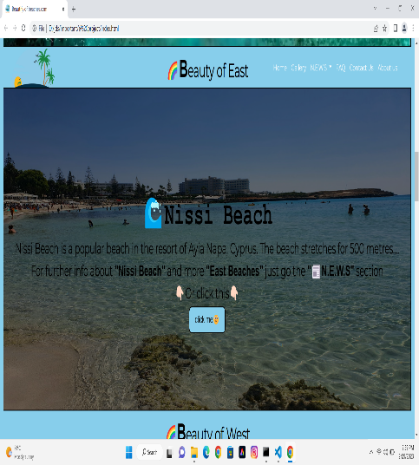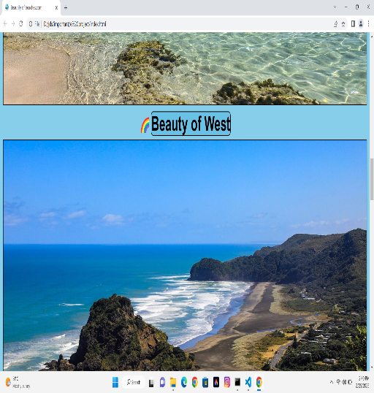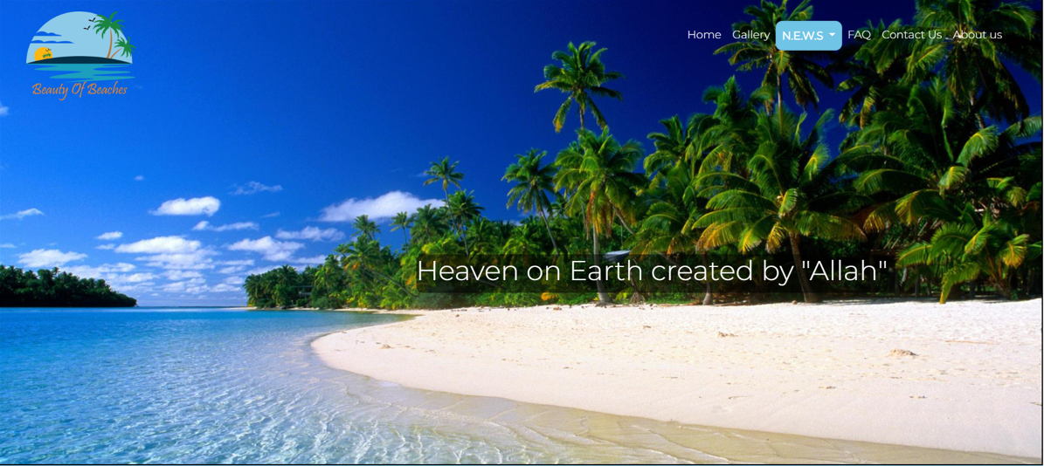

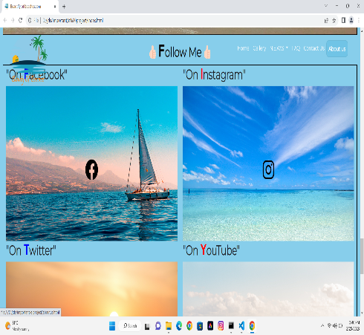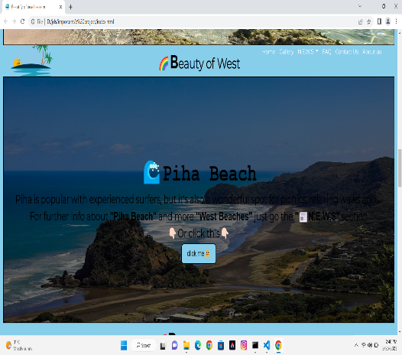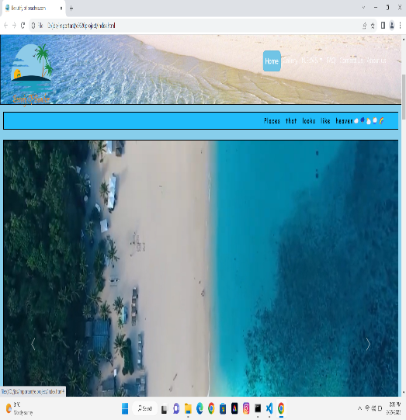

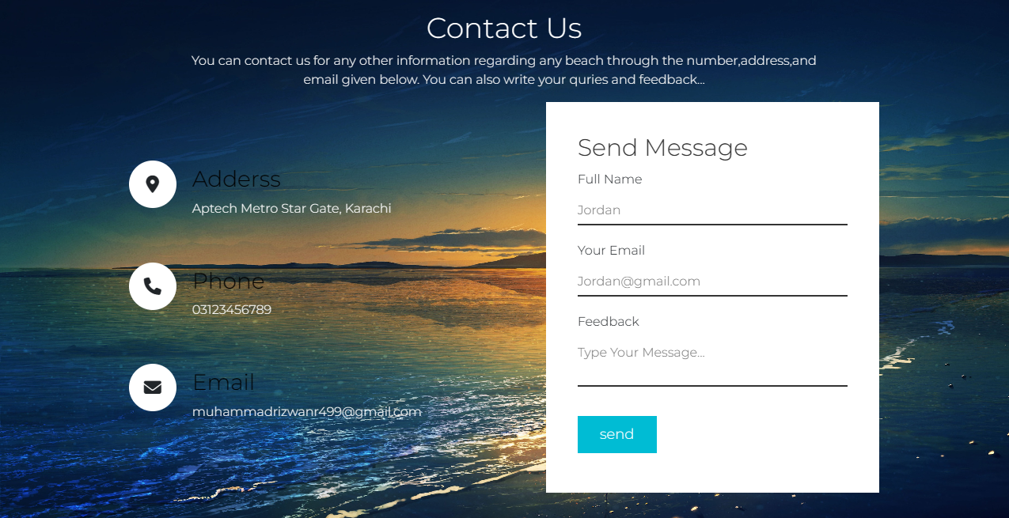

**CONTACT US**

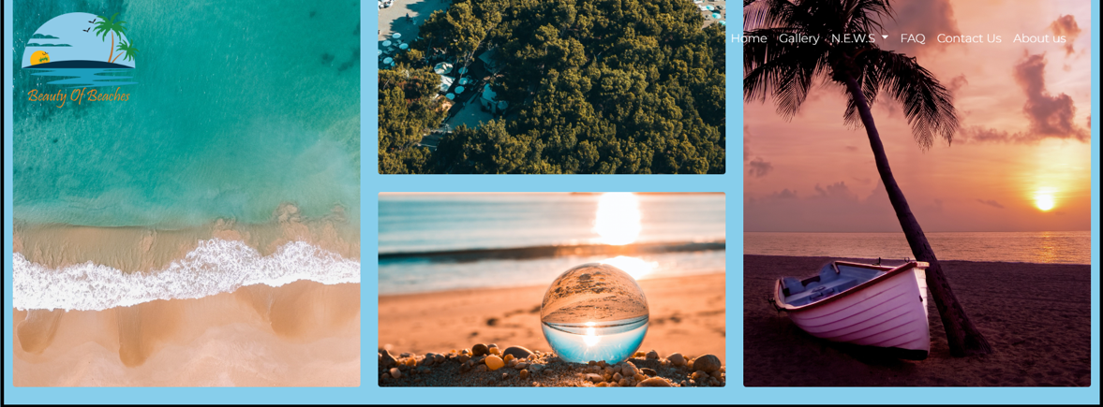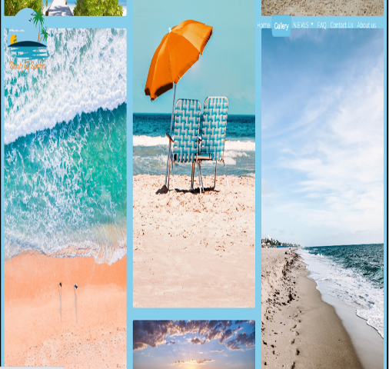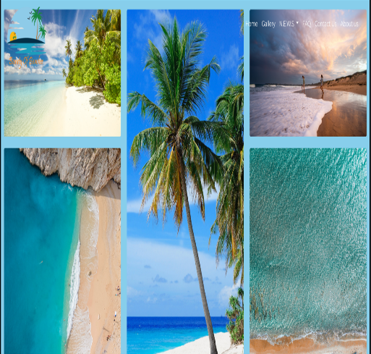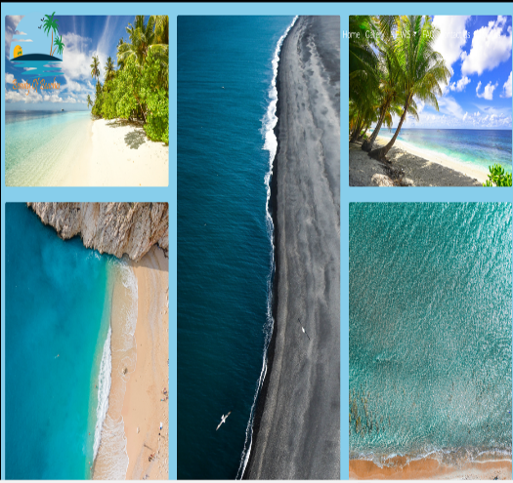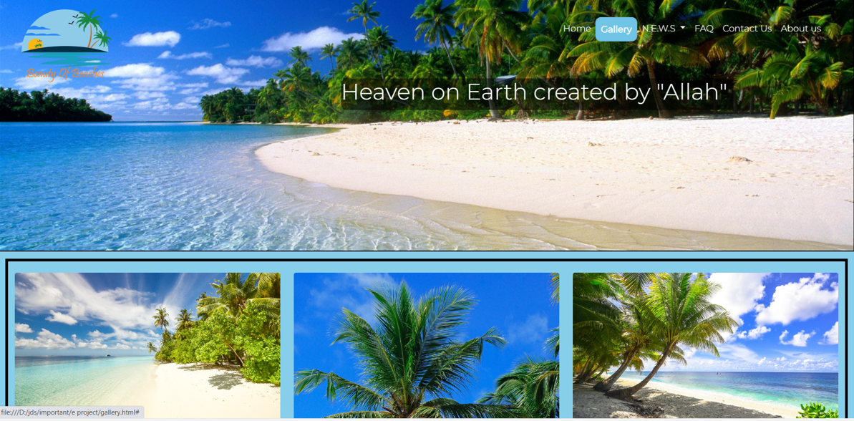

**GALLERY**

**FAQ**



**NORTH**

**EAST**

**WEST**

**SOUTH**

**SEARCH**

**ABOUT US**